Personal Expense Tracker Application

***Abstract -* Expense tracker is an android based application. This application allows the user to maintain a computerized diary. Expense tracker application which will keep a track of Expenses of a user on a dayto-day basis. This application keeps a record of your expenses and also will give you a category wise distribution of your expenses. With the help of this application user can track their daily/weekly/monthly expenses. This application will also have a feature which will help you stay on budget because you know your expenses. Expense tracker application will generate report at the end of month to show Expense via a graphical representation. We also have added a special feature which will distributes your expenses in different categories suitable for the user. An expense history will also be provided in application.**

***Index Terms -* Add Expenses, Java, Xml, MySQL, View**

**Analytics, Add Category, Filter Transaction**

# 1.INTRODUCTION

Now a day’s people are concerned about regularity of their daily expenses. This is done mainly for keep a track of the users’ daily expenses to have a control of users’ monthly expenses. We have developed an android application named as “Expense Tracker Application” and this application is used to manage the user‘s daily expenses in a more coherent and manageable way [10]. This application will help us to reduces the manual calculations for their daily expenses and also keep the track of the expenses. With the help of this application, user can calculate his total expenses per day and these results will stored for unique user. As the traditional methods of budgeting, we need to maintain the Excel sheets, Word Documents, notes, and files for the user daily and monthly expenses. There is no as such full-fledged solution to keep a track of our daily expenses easily. Keeping a log in diary is a very monotonous process and also may sometimes lead into problems due to the manual calculations. Looking on all the above given conditions, we are trying to satisfy the user requirements by building a mobile application which will help them reduces their burdens. “Expense Tracker Application” is an application where one can enter their daily expenses and end of the day, they know their expenses in charts.

# 2.BACKGROUND STUDY

The idea of developing this project in mobile platform for user convenience. Because whenever they make expenses immediately, they add in mobile application. Some of the concerns maintaining a personal expense is a BIG problem, in daily expenses many times we don’t know where the money goes. Some of the conventional methods used to tackle this problem in normal circumstances are like making use of a sticky notes by common users, Proficient people deals with this kind of problems by using spreadsheets to record expense and using a ledger to maintains the large amounts data by especially by expert people. As this shows that it is various methods used by different people. This makes using this data contrary. There is still complication in areas like there is no assurance for data compatible, there are chances of crucial inputs can be missed and the manual errors may sneak in. The Data recorders are not always handled, and it could be hectic process to have overall view of those expenses. We believe a handy design and a handy mobile

application which handles these troubles. Such that app is capable of recording the expenditure and giving broad view with easy to use the user interface and this application is intelligent enough to shows the history of expenses noted in the app [12].

# 3.RELATED WORK

The mobile applications that are available in the market are very helpful to the smartphone users and make their life accessible. The expense tracker is also one of those applications, which much extent in daily life.[8] As there are many similar apps available today, we added some innovative components to make our application unique, easy to use and coherent. Apart from adding unique features like view analytics and expense history in the application, we also added features like multiple user accounts. We have an idea of making use of application for the purpose of survey in the field of expenses of user. This idea serves as a main objective of research project [1][2]. The research also includes view the reports at the form of charts.

# 4.EXISTING SYSTEM

The Expense tracker existing system does not provide the user portable device management level, existing system only used on desktop software so unable to update anywhere expenses done and unable to update the location of the expense details disruptive that the proposed system provides [6]. In existing, we need to maintain the Excel sheets, CSV files for the user daily, weekly and monthly expenses. In existing, there is no as such complete solution to keep a track of its daily expenses easily. To do so a person as to keep a log in a diary or in a computer system, also all the calculations need to be done by the user which may sometimes results in mistakes leading to losses. The existing system is not user friendly because data is not maintained perfectly. But this project will not have any reminder to remain a person in a specific date, so that is the only drawback in which the remainder is not present. This project will be an unpopulated information because it has some disadvantages by not remind a person for each and every month. But it can used to perform calculation on income and expenses to overcome this problem we propose the new project.

# 5.METHODOLOGY

Expense Tracker is going to be a mobile application so that It can be accessed any time required [11]. This application will have a two-tier architecture: first one is the database tier, where all the data and financial data will be stored. Second it will be the user interface which will support the application user communicate with the system and also store Information in the database. The proposed system should operate offline so it can be accessed at any time without internet availability. The proposed system should provide different categories for the user to select from and they can enter the amount and mode of payment. This system should be able to analyze the information, provide analytics on which category did the user spent most of their money. The proposed system should provide a user interface where the user could store and observe their past expenses. To create this system, we will use the android studio and it[13].It will be written in Java, Xml. MySQL will be the database used.

5.1. SEQUENCE DIAGRAM

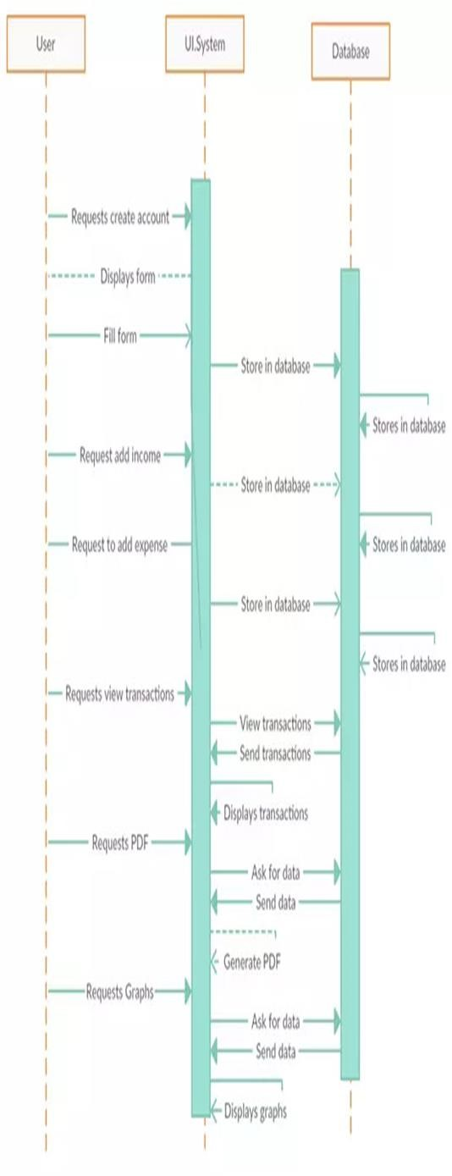

5.2. ACTIVITY DIAGRAM

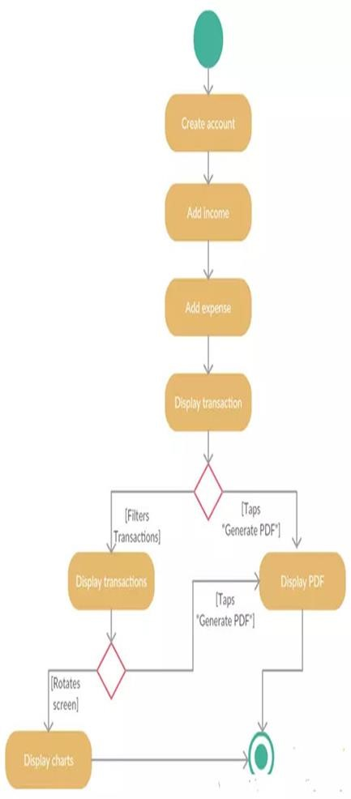

5.3. FEASIBILTY STUDY

Technology has contaminated every area of our life. We are hang on technology for almost every aspect of our life. Smart phones and tablets are assemble the marketplace worldwide today. Nowadays, mobile technology has become extensive, and it is easier than a personal computer or laptop, which is needed to connect to the especial location. In fact, mobile devices are becoming an essential part of daily life and routine because it is accessible to carry all the time anywhere rather than a laptop and personal computer. Furthermore, they can access data anytime and anywhere using data plan provided by telecom provider of wireless connections. Why not daily budgeting? We have all seen our previous generations write down their daily expenditures in a notebook. Here we provide an environment where, in a few clicks can add their expenses.

5.4. MODULES

5.4.1. MULTIPLE ACCOUNTS

Users can create multiple accounts. In the account tab. User has the option available for creating a new account and Users will click the “+” sign button then a dialog will appear on the screen and the user could enter the name of the account then that name will be saved in the account tab. [7] If a user wants to delete the particular account, then the user has to click the account name user want to delete. Then that account will be deleted.

5.4.2.ADD EXPENSES

This module deals with adding expenses. Here The user has adding daily expenses. But there is a condition if the user hasn’t selected the category yet then the user can’t enter expenses. When the user enters any transaction then that transaction will be added in Transaction tabs. If the user wants to delete that transaction, then the user has to long click the transaction will be deleted from tabs.

5.4.3.ADD CATEGORY

In this module user can add the categories. Every expense stored under the categories. Then only we could filter the details easily. Already some categories pre-defined in the application. If user want to add more categories that also available in the application.

5.4.4. FILTER TRANSACTION VIEW

In the transaction tab, the user can filter the transaction. In the tab, users could select the day, month and year then click the filter button and according to the day and month, year transactions will be appeared. If the user wants to filter the transactions only on the basis of that day, for example, userselected Sunday then all transactions will appear that were made on Sunday.

5.4.5. VIEW ANALYTICS

The user has pie chart option available for graphical representation. If the user clicks the view analytics it will redirect to the statistics. When the user rotates the phone statistics will initiated and it shows the graphical representation in the form of pie chart. Pie chart it could contains a colored and percentage view.

5.4.6.PDF REPORT

In the transaction, the tab user has an option available for creating a report in PDF. Users click on the PDF button then PDF report will be generated to the user and also user could view that report and that report will be automatically saved in the device.

# 6.CONCLUSION

Thus, we have developed such type of android application which help the users to reduces their effort of handling daily expenses. That the application will have various components of updating and viewing users’ expenditures. As part of research, we considered adding certain components to the application to make it more useful to the user. Some of the extra Components are like enabling users to register to the application using existing email or social network account, it will synchronize the users profile data to the application [3][4].

# 7.FUTURE ENHANCEMENT

The Future Enhancements of the application can be allowed to support in all the upcoming android versions [9]. History can be set to view all the details in the app even if the particular data is deleted from the database. Statistics could be prepared based on the Income, Expense details of the user. Sharing files via Bluetooth, WhatsApp can be allowed. Printing the details of the particular income or expense details can be made. Some of the extra components are like enabling users to register to the application using existing email or social network account, it will synchronize the users profile data to the application [3][4].